**SYST 17796 TEAM PROJECT**

Team Name: Sunday Afternoon

Deliverable 3

August 14, 2021

Contents

UML Class Diagram 1

Git Repository 1

**Group Members:**

Jinyoung Jeon

Juyoung Jung

Tamara Dang

Winston Martinez

# UML Class Diagram

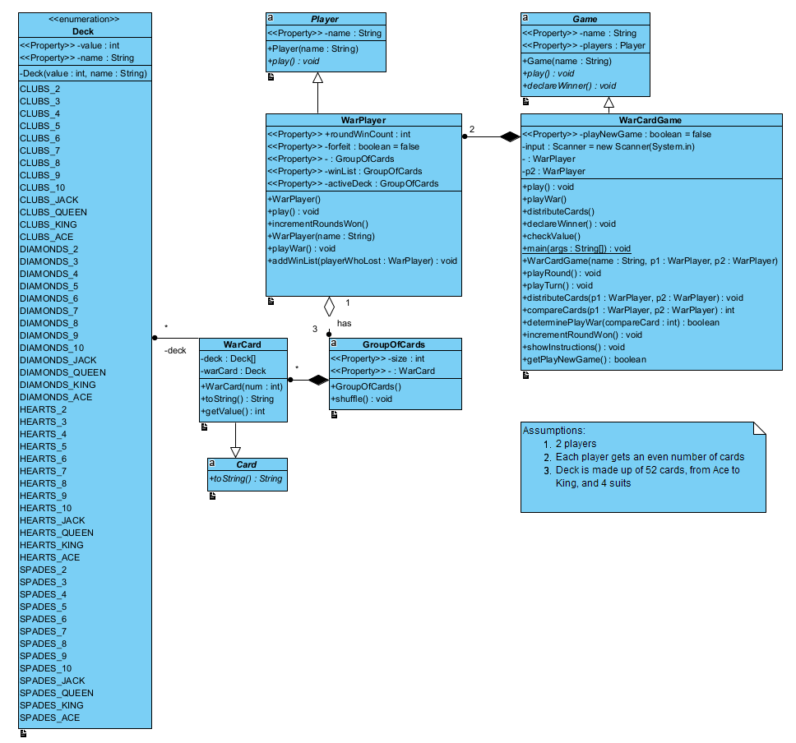

# Git Repository

<https://github.com/winstonmartinez/SundayAfternoonCodingProject.git>